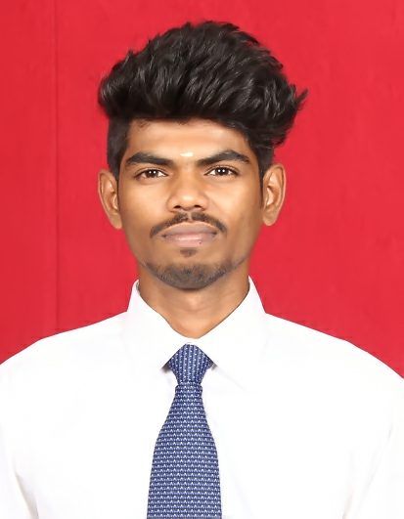

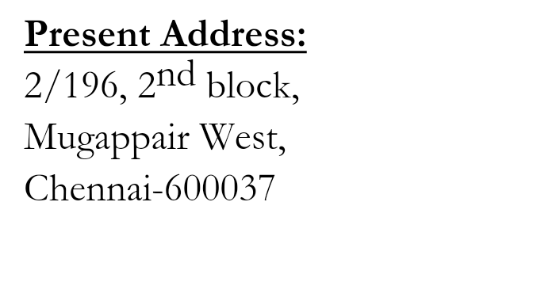



**CAREER OBJECTIVE**

To make use of my interpersonal skills to achieve goals of a company that works for customer satisfaction and customer experience

B**ASIC ACADEMIC CREDENTIALS**

|  |  |  |  |
| --- | --- | --- | --- |
| **Qualification** | **Board/University** | **Year** | **Percentage** |
| B.Tech  (Biotechnology) | Sathyabama institute of science and technology | 2020 | 6.5/10 |
| Higher secondary school | Green Valley Matriculation Higher Secondary School | 2016 | 63.25% |
| High School | Green Valley Matriculation Higher Secondary School | 2014 | 86.4% |

**EXPERIENTIAL LEARNING ( INTERNSHIP/IMPLANT TRAINING PROGRAM)**

**1)University Name:- Anna University(Chennai)**

**:- Emerging Trends in Nanotechnology.**

**2)Company Name :-TTK Healthcare pvt. Ltd. (Chennai)**

**:- HPLC Training Program**

**3)Company Name :- Royal Biotech Research centre(Chennai)**

**:- Program on Molecular Biology Techniques.**

**ACHIEVEMENTS**

* Presented e-poster in International Conference In Sathyabama Institute Of Science And Technology.
* Participated in The Inter-College Symposium On Emerging Trends In Nanotechnology SIST(Chennai).
* Participated in The National Conference(NASHE-17) in SIST(Chennai)

**AREA OF INTEREST**

* **Genetic engineering**
* **Information Technology**

**WORKSHOPS ATTENDED**

* Emerging Trends In Nanotechnology, in QUANTA’19, Anna University, Chennai
* Analysis of Gene Expression using Quantitative PCR, SRMIST, Kattankulathur, Tamil Nadu

**INTERPERSONAL SKILL**

* + Ability to rapidly build relationship and setup trust
  + Confident and Determined
  + Ability to cope up with different situations.
  + Ability to promote teamwork
  + Capable to lead a team

**LANGUAGES KNOWN:**

**1)TAMIL**

**2)ENGLISH**

**PERSONAL DETAILS**

* **Date of Birth :-** 14th January, 1999
* **Nationality/Religion :-** Indian / Hindu
* **Interest & Hobbies :-** Sketching images, Reading.

**DECLARATION**

I do hereby declare that the above information is true to the best of my knowledge**.**

**BHUVANESH.J**

**Place:**

**Date:**